Sprint 3 Plan

Marine Plastics Monitor

Marine Plastics Team

Sprint Starts: 3/4/18

Sprint Ends: 3/17/18

**Goal:** To be able to display the data points on a map with pinpoints to where the specific beach is located.

**User Story 1:** **As a member of Clean Oceans I want to view the posted data on a map to have easy viewability of my necessary information. 13**

Task 1: Research Google Map’s API 1

Task 2: Connect the google map image onto the landing page 5

Task 3: Create a schema to pull all the data’s location 8

Task 4: Figure out how to show a pinpoint on the map 5

Task 5: Connect the logic behind pulling all the locations and the map’s pinpoint 5

**User Story 2: As a member of Clean Oceans I want to be able to filter the data by different areas so I can view the data clearly. 8**

Task 1: Create a filter bar with filter options 4

Task 2: Create the logic behind each filter option 10

Task 3: Connect the logic to the data’s locations 6

**Initial Burnup:**

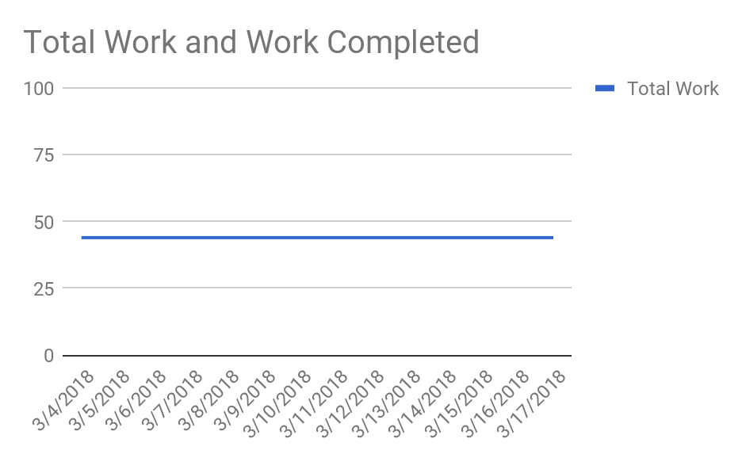

**Scrum Board:**

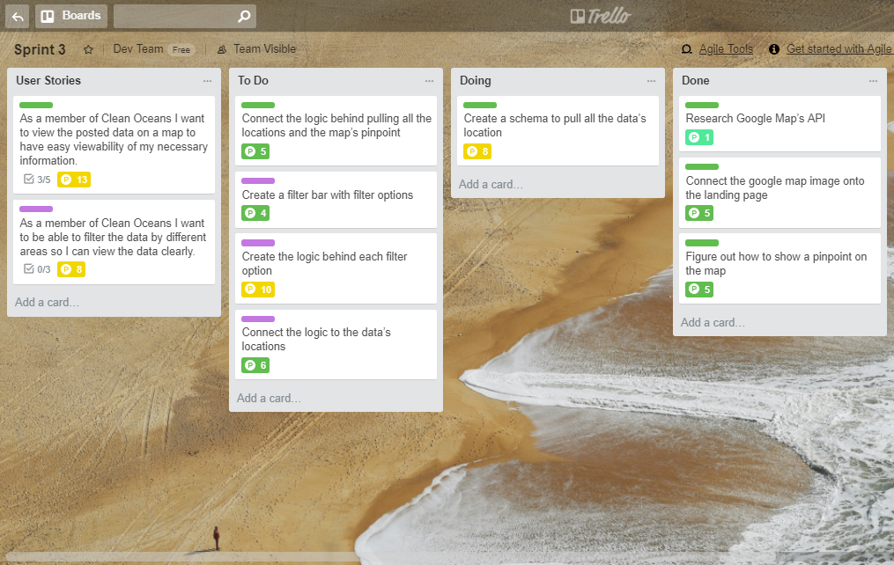

**Scrum times**:

Mondays @ 3:30

Thursday @ 10:10

Saturdays @ 11

TA Meeting: Thursday @ 10:30

Sponsor Meeting: Friday @ 1